WEATHER CLIMATE WATER |   World Meteorological Organization  WORLD METEOROLOGICAL CONGRESS  Nineteenth Session  22 May to 2 June 2023, Geneva | Cg-19/Doc. 3.2(2)
Submitted by:
P/INFCOM, through Executive Council
11.IV.2023
DRAFT 1
AGENDA ITEM 3: STRATEGIC PLAN AND BUDGET 2024–2027
AGENDA ITEM 3.2: Strategic Initiatives

WMO-COORDINATED GLOBAL GREENHOUSE GAS MONITORING INFRASTRUCTURE

Summary
Document presented by: President of INFCOM through the Executive Council
Strategic objective 2020–2023: 2.3
Financial and administrative implications: within the parameters of Strategic and Operational Plans 2024–2027.
Key implementers: INFCOM, in consultation with SERCOM and RB
Time frame: 2023–2027
Action expected: Review and adopt the proposed draft resolution

GENERAL CONSIDERATIONS

Rationale
- Currently, monitoring of the implementation of the Paris Agreement is entirely based on bottom-up estimation of anthropogenic greenhouse gas emissions, using methodologies established by the Intergovernmental Panel on Climate Change (IPCC). These estimates are generally considered to be of good quality in industrialized countries. However, in many developing countries, the underlying economic data required for bottom-up estimation are unavailable, and the methodology thus cannot be applied. In addition, natural sources and sinks of greenhouse gases, many of which are associated with even larger fluxes, cannot readily be monitored using bottom-up estimation. This leads to continued uncertainty about some of the processes behind the continued rise in atmospheric concentration of greenhouse gases, about the effectiveness of various kinds of mitigation action, and about how natural sources and sinks of greenhouse gases may respond to the ongoing climate change.
- Top-down greenhouse gas monitoring provides supplementary methodology for estimating when and where greenhouse gases enter and exit the atmosphere, based on the direct use of observations of atmospheric greenhouse gas concentrations in conjunction with atmospheric modelling and data assimilation. The models, data assimilation, observing network and data exchange that is required for top-down monitoring of greenhouse gases all have much in common with their parallels in the World Weather Watch, which has been successfully operated by the WMO Members for 60 years.
- Top-down monitoring is now becoming a mature methodology and it is being implemented operationally by one group of WMO Members, with pre-operational activities being undertaken by at least three other Members. However, the surface-based parts of the greenhouse observing system are still relatively weak, and there is no consolidated design of an integrated observing network across Earth System domains and platforms that would fully meet the requirements. Moreover, there is currently no coordination framework through which the ongoing operational and pre-operational activities would be able to leverage one another for improved product quality and increased ability to provide transparent, high quality and authoritative data on greenhouse gas fluxes to the Parties of the Paris Agreement.
- In view of these shortcomings, and in recognition of WMO’s experience with weather prediction, climate monitoring and greenhouse gas research, the Greenhouse Gas Monitoring Symposium held in Geneva, 30 January – 1 February 2023 and attended by more than 170 stakeholders from academia and public and private sectors, issued a call for WMO to take the lead in coordinating an international effort to establish top-down coordinated greenhouse gas monitoring in support of the implementation of the Paris Agreement
Expected action
- Based on the above, Congress may wish to adopt draft Resolution 3.3(2)/1, adopting the concept of a WMO-coordinated top-down greenhouse gas monitoring framework, and requesting the development of an implementation plan, to be submitted to EC-78.

DRAFT RESOLUTION

Draft Resolution 3.2(2)/1 (Cg-19)

WMO-coordinated Global Greenhouse Gas Monitoring Infrastructure
THE WORLD METEOROLOGICAL CONGRESS,
Recalling the WMO Strategic Plan 2020–2023 (WMO-No. 1225) WMO Strategic Plan 2024–2027 (Cg-19/Doc. 3.1(1)),
Recognizing the growing societal importance of greenhouse gas monitoring in support of improving our scientific understanding of the Earth System, and the urgent need to strengthen the scientific underpinning of mitigation actions taken by the Parties to the United Nations Framework Convention on Climate Change (UNFCCC) and the Paris Agreement,
Recognizing further:
(1) WMO’s long-standing activities in greenhouse gas monitoring, research and provision of related services under the auspices of the Global Atmosphere Watch (GAW) established in 1989 and its Integrated Global Greenhouse Gas Information System (IG³IS), the development of which was initiated by Resolution 46 (Cg-17) - Integrated Global Greenhouse Gas Information System,
(2) The long-standing activities of international partners engaged in greenhouse gas monitoring activities, scientific research and analysis, modelling, and on scientific assessments and climate projections,
(3) The important role of the ocean, the land biosphere including water bodies and the permafrost areas in the carbon cycle, and thus the need to undertake greenhouse gas monitoring within an integrated Earth System framework in order to be able to account for natural sources and sinks, both as they currently operate and as they will change as a result of a changing climate,
(4) The unique position of WMO, thanks to its experience from the World Weather Watch (WWW), the GAW and the Integrated Global Greenhouse Gas Information System (IG³IS), to coordinate efforts within a collaborative framework, to leverage all existing greenhouse gas monitoring capabilities – space-based and surface-based observing systems, all relevant modelling and data assimilation capabilities – in an integrated, operational framework in order to optimize the benefits from investment in these capabilities, and reduce uncertainties in observations, priors and models over time,
(5) The significant policy implications of greenhouse gas monitoring data, and thus the need for any greenhouse gas monitoring to be supportive of and complementary to existing national government reporting under the UNFCCC and Paris Agreement, including actively seeking data inputs from UNFCCC and Paris Agreement national focal points to ensure the best possible country-specific data inputs, and be carried out in international coordination, with full transparency, and in accordance with Resolution 1 (Cg-Ext.(2021)) - WMO Unified Policy for the International Exchange of Earth System Data and its call for free and unrestricted international exchange of Earth system data,
Acknowledging the need to substantially improve the geographic coverage of greenhouse gas observations in under sampled regions and, especially in developing countries,
Noting that the 2022 Global Climate Observing System Implementation Plan (GCOS-No. 244), welcomed by the fifty-seventh Session of the UNFCCC Subsidiary Body on Scientific and Technological Advice (SBSTA-57) held in Sharm El Sheikh in November 2022, includes a call to (Action F5): Develop an Integrated Operational Global Greenhouse Gas (GHG) Monitoring System,
Also noting that the Sharm El Sheikh Implementation Plan from the twenty-seventh Conference of the Parties to the UN Framework Convention on Climate Change and the COP27 decision on the Implementation of the Global Climate Observing System emphasize {…} the need to enhance coordination of activities by the systematic observation community and the ability to provide useful and actionable climate information for mitigation, adaptation and early warning systems {…},
Noting further the communique adopted on 15 November 2022 by the Climate and Clean Air Coalition Ministerial, which “welcome[d] the efforts of WMO and the broader greenhouse gas community to strengthen the GHG information basis for decisions on climate mitigation and collaborate on the development of a framework for sustained, internationally coordinated global greenhouse gas monitoring”,
Noting with appreciation the concept development undertaken by the joint Study Group on WMO Greenhouse Gas Monitoring (SG-GHG) between the Commission for Observation, Infrastructure and Information Systems (INFCOM), the Commission for Weather, Climate, Water and Related Environmental Services and Applications (SERCOM), and the Research Board (RB),
Noting further with appreciation complementing efforts to engage the international scientific and user communities in the development of the concept, including the organization of the workshop on the case for a coordinated Global Greenhouse Gas Monitoring Infrastructure held 10 – 12 May 2022 and the WMO International Greenhouse Gas Monitoring Symposium held 30 January – 1 February 2023, recommendations and outputs of which are reflected in the concept,
Noting further the statement, as contained in document Cg-19/INF 3.2(2), published by a broad group of 170 greenhouse gas monitoring stakeholders attending the WMO International Greenhouse Gas Monitoring Symposium,
Having examined Recommendation 4(3)/1 (EC-76) - WMO-coordinated Global Greenhouse Gas Monitoring Infrastructure,
Endorses the concept for the WMO-coordinated Global Greenhouse Gas Monitoring Infrastructure, the Executive Summary of which is attached as the annex to the present resolution;
Requests INFCOM, SERCOM and the RB, via the joint Study Group, to further develop the concept through a detailed implementation plan, building on existing capabilities and ongoing activities under the GAW, including the Integrated Global Greenhouse Gas Information System (IG³IS), and other relevant international frameworks, and to bring back the draft plan to the Executive Council for its review and approval; the plan should include the following key elements:
(1) Emphasis on WMO’s unique role in establishing best practices for measurement, data, and reporting standards, validation and intercomparison of information products, and other best practices needed to support global greenhouse gas monitoring infrastructure and actionable information services;
(2) Emphasis on the science for services element, e.g. via use of the IG³IS framework to support stakeholder and user engagement and capacity-building to enhance the information uptake related to the greenhouse gas monitoring decision and policy needs. In particular, the plan should elaborate on how the Global Greenhouse Gas Monitoring Infrastructure and IG³IS initiatives can deliver actionable information to other UN bodies including UNFCCC, IPCC, and the United Nations Environment Programme (UNEP), including in support of the Paris Agreement Global Stocktake, as well as to other national and subnational government and private sector entities, including avenues through which Members can supply best available data inputs for modelling and data assimilation capabilities used to generate the information;
(3) Clear articulation of WMO’s role as a coordinator of activities undertaken by Members, (paragraph 5.2 in the annex to the resolution) and on its role in providing avenues through which Members can supply relevant data inputs to these systems to reduce uncertainties in their results over time;
(4) Integration of the components of the Global Greenhouse Gas Monitoring Infrastructure within appropriate WMO-coordinated systems, the WMO Integrated Global Observing System (WIGOS), the WMO Information System (WIS), and the WMO Integrated Processing and Prediction System (WIPPS);
(5) Acknowledgement that all operational components of the Global Greenhouse Gas Monitoring Infrastructure will be managed by Members;
(6) Assurance that the plan will support Members in bringing the coordinated Global Greenhouse Gas Monitoring Infrastructure into a normal operational status at the end of a defined implementation phase;
Requests the Executive Council to keep the implementation plan and resulting actions under review and provide guidance and oversight to INFCOM and relevant WMO bodies during the implementation phase, subject the approval of the plan;
Urges Members to contribute to the ongoing development of the plan, through the work of INFCOM, SERCOM and the RB via the Joint Study Group and in consultation with their UNFCCC and Paris Agreement national focal point;
Recognizes that the implementation of the Global Greenhouse Gas Monitoring Infrastructure is subject to the outcome of budgetary decisions or the Secretary-General being able to identify efficiencies;
Requests the Secretary-General:
(1) To allocate the necessary resources, ensuring adequate cross-cutting activities in the Secretariat, to support the further development of the concept through the detailed implementation plan, to the extent possible;
(2) To further strengthen close collaboration and coordination with relevant United Nations agencies and other international partners engaged in greenhouse gas monitoring and modelling activities and, subject to approval of the plan by the Executive Council, mobilize partner resources to implement the Global Greenhouse Gas Monitoring Infrastructure;
(3) Subject to the approval of the plan by the Executive Council, to engage with stakeholders at international forums, such as the Conference of the Parties to the UNFCCC (COP), to promote the uptake and use of the data and products generated by this infrastructure;
Calls on partner organizations to contribute to the development of the implementation plan for a coordinated Global Greenhouse Gas Monitoring Infrastructure.
_______________
Annex: 1

Annex to draft Resolution 3.2(2)/1 (Cg-19)

A WMO-COORDINATED GLOBAL GREENHOUSE GAS MONITORING INFRASTRUCTURE
Concept Note, Executive Summary
WMO Joint Study Group on Greenhouse Gas Monitoring

1. Background
The three most important GHGs influenced by human activities are carbon dioxide (CO₂), methane (CH₄), and nitrous oxide (N₂O). Increasing abundances of these gases in the environment are the main cause of the observed climate change and related impacts according to the Intergovernmental Panel on Climate Change (IPCC, ref AR6).
At the twenty-seventh Conference of the Parties (Sharm El Sheikh, November 2022), Parties “Emphasizes {…} the need to enhance coordination of activities by the systematic observation community and the ability to provide useful and actionable climate information for mitigation, adaptation and early warning systems {…}”.

2. Need for improved quantitative knowledge of greenhouse gas cycles
The largest part of the anthropogenic forcing on the climate system is due to the increase in atmospheric concentrations of long-lived greenhouse gases. Therefore, global monitoringof these gases is of prime importance. However, these concentrations are not determined by anthropogenic emissions alone. GHG concentrations are strongly influenced also by the natural processes, which in turn are influenced by climate and other environmental changes. The quantitative knowledge about the strength of some of the GHG sources and sinks has large uncertainties, both as they currently operate and the extent to which they will change in the future in response to diverse environmental factors, including climate change.
A WMO-coordinated Global GHG Monitoring Infrastructure (GGMI) based on established methodology and standardized protocols will provide a wealth of quantitative data to help improve our understanding of GHG cycles. The GGMI will consolidate existing measurement and analysis capabilities to provide estimates of total net greenhouse gas fluxes on a global scale at a relatively high resolution in space and time. Improved understanding of the fluxes will allow for better prediction of their long-term future climate trajectories, with potentially strong implications for the required mitigation activities here and now.
The GGMI data products will be generated utilizing methodologies that extend those already developed by the research and operational communities. The WMO Global Atmosphere Watch (GAW) has 50 years of experience in developing the GGMT (Greenhouse Gas Measurement Techniques) guidelines. Flux products based on observations will complement existing estimates of anthropogenic emissions developed by inventory builders or through process-based models.

3. A coordinated Global Greenhouse Gas Monitoring Infrastructure
3.1. Main components of the Global GHG Monitoring Infrastructure
In its initial configuration, the GGMI will consist of four main components:
(1) A comprehensive sustained, global set of surface-based and satellite-based observations of CO₂, CH₄ and N₂O concentrations, total column amounts, partial column amounts, vertical profiles, and fluxes and of supporting meteorological, oceanic, and terrestrial variables, internationally exchanged as rapidly as possible, pending capabilities and agreements with the system operators;
(2) Prior estimates of the GHG emissions based on activity data and process-based models;
(3) A set of global high-resolution Earth System models representing GHG cycles;
(4) Associated with the models (item 3), data assimilation systems that optimally combine the observations with model calculations to generate products of higher accuracy.
The individual model systems that will be part of the GGMI will each deliver at least the following outputs in common standard formats:
• Monthly CO₂ net fluxes between the Earth surface and the atmosphere with 1x1 degree horizontal resolution delivered with maximum a delay of one month
• Monthly CH₄ net fluxes between the Earth surface and the atmosphere with 1x1 degree horizontal resolution delivered with a delay of one month
• 3D fields of CO₂ and CH₄ abundance with hourly resolution and data latency to be defined (tentatively on the order of a few days)
• N₂O abundances and net fluxes with resolution and latency still to be defined
In addition, efforts are underway to develop capabilities to further separate these net fluxes into source-apportioned emissions, which would lead to additional operational products in the future. Per WMO's data policy (Resolution 1 (Cg-Ext(2021)) and in the interest of maintaining transparency as required under the Paris Agreement, the data are expected to be made available to all interested users on a free and unrestricted basis.
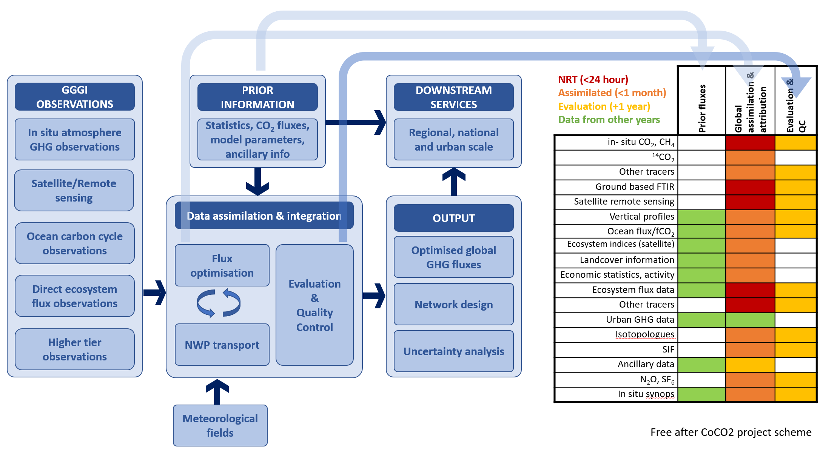
Figure 1. Conceptual connections between the different data streams and functions of the GGMI. Example data and data latency based on the CoCO2 prototype; for the GGMI this will be subject to further analysis and agreement with system operators.
3.2 Input data: observations and prior information.
3.2.1 Required set of observable parameters.
To support implementation of GGMI global atmospheric composition observations are essential and must be provided with sufficient spatial and temporal coverage. It is critical that measurements meet accuracy and precision standards and that their characteristics are documented per the WMO Integrated Global Observing System (WIGOS) Metadata Standard. As natural sources and sinks help determine GHG concentration and are often of larger magnitude in space and time than the anthropogenic sources, the system should also provide adequate spatial coverage to detect changes in natural terrestrial and ocean fluxes, associated with possible carbon-climate feedbacks.
The detailed requirements for the observations will be further refined using the WMO Rolling Review of Requirements process once the GGMI moves to the implementation. These requirements will be largely driven by the desired quality of the model output. A core principle in the GGMI concept is that all participating modelling centres must be provided access to the same distributed set of input data described below. However, data selection, pre-processing and data management will be specific to each system/centre due to differences between their individual setups.
The total cost of a fully deployed observing system outlined below cannot be credibly estimated at this point. The full network design will not be known until the GGMI has moved to implementation, and the impact of commoditization of sensors due to the scale of the GGMI cannot be predicted. Rather than drastically expanding the observational capabilities, the most important initial step for the GGMI will be to establish adequate timely international exchange of all already existing GHG observations, both surface- and space-based. A mix of funding opportunities may be pursued, including Government support similar to current funding of weather and climate observation and philanthropy. Private sector financing may be driven by expected developments in reporting obligations under Science Based Targets initiative (SBTi) that is used to align private sector activities with Net Zero strategic planning goals and the Task Force on Climate Related Financial Disclosures (TCFD) that is used by the global financial services community to align the use of capital with the goals of the Paris Climate Accord
The minimum observable parameters can be summarized in five categories (A is the highest priority and E is the lowest). The minimum system should have adequate observations from at least category A (in situ atmospheric composition), B (remotely sensed atmospheric composition) and C (ocean carbon cycle). An adequate number of stations should provide observations of the higher tier (category E), based on the overall network. All stations across the different categories should be equipped with automated weather stations to support data interpretation and model validation as well as the required atmospheric transport modelling.
The initial emphasis will be on observations related to CO₂, CH₄, and N₂O, the three of which in 2021 accounted for 90% of the radiative forcing on the climate system.
A. Ground based measurements of GHGs
A global (over land and ocean) in situ network of adequate spacing, accuracy and precision providing long-term observations of the atmospheric abundance of CO₂, CH₄ as mole fractions in dry air is the basic minimum requirement.
B. Remote sensing and vertically resolved observations of GHGs
Having a combination of remotely sensed (both from space and from the surface) and in situ measurements is important, as their respective strengths and weaknesses tend to complement each other well. Satellite observations provide broad global coverage, but are in general only available in cloud-free conditions during short intervals around local noon every few days.
C. Ocean carbon cycle observations
Accurate measurements of ocean fCO₂ (CO₂ fugacity) are scarce and sparsely distributed. These efforts are coordinated through the International Ocean Carbon Coordination Project (IOCCP) and the Global Ocean Observing System (GOOS). The data are essential for determining the development of the global greenhouse sink and source terms from the oceans.
D. Direct GHG flux observations
Direct flux observations obtained using for example eddy covariance techniques provide key input to the ocean and ecosystem models that are used for production of prior flux information to the inversion systems. Direct flux observations above ecosystems or urban areas can be used for parameterization or validation purposes. Direct flux observations in the ocean that characterize status and variability in the ocean water column are also required.
E. Higher tier observations
Beyond the base measurement stations, the network should contain a mix of enhanced higher tier stations. This should include regular vertical profile measurements in the atmosphere using aircrafts, AirCore and other techniques and include vertical profile measurements in the ocean. Data from emerging techniques used for hot spot detection may also be added to the mix (see Section 4).
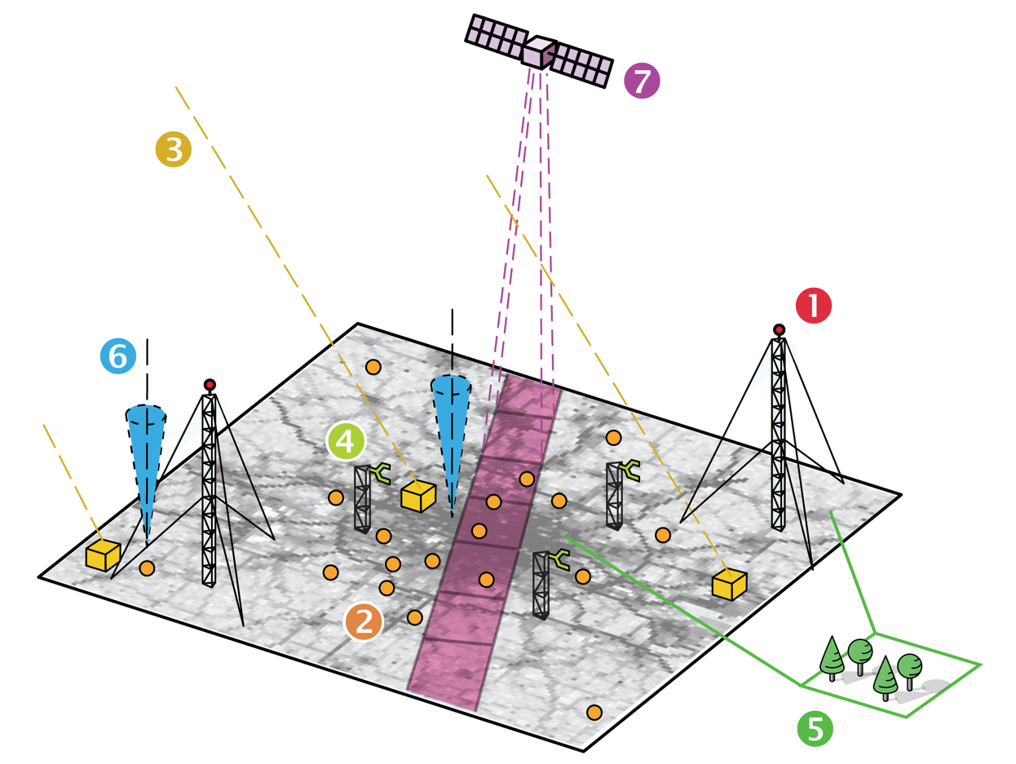
Figure 2. In complex situations, like for megacities as illustrated here, a complex measurement setup with a combination of all observation elements mentioned in this chapter is used.
3.2.2 Prior models and supporting data
The core of the GGMI is model ingestion of observational data to estimate and reduce the uncertainty in the GHG fluxes. This analysis depends critically on the quality of ancillary data and the prior flux information and estimates of their uncertainty. The quality of prior information is critical as the prior uncertainty estimates determine the bandwidth in which the optimized fluxes are allowed to deviate from the prior fluxes. Prior fluxes should be generated using multiple independent models to have adequate representation of the uncertainty. Such estimates should also have a temporal resolution that captures the processes driving flux variability (e.g., have adequate representation of diurnal cycle for biogenic fluxes). Common set of the fossil fuel related fluxes and their uncertainties utilizing existing inventories is also recommended.
3.3 Core modelling capabilities
3.3.1 Global system component: Earth System Model
The Earth System models simulate the transport and relevant source/sink terms of atmospheric constituents (including GHGs such as CO₂, CH₄ and N₂O, but in many cases also natural and man-made aerosols and other chemical species), their interactions and transformation across all the parts of the Earth System. Depending on the degree of complexity of the individual model, these processes may be represented through external datasets (most anthropogenic emissions, volcanic eruptions, active wildfires, aquatic and terrestrial biota…) or through more or less sophisticated parameterizations. The scale of the processes relevant for GHG fluxes range from planetary down to city-wide or even smaller scales. For the GGMI, the target resolution of the output will be initially at 1 deg x 1 deg, while some of the participating model systems may operate at higher resolution depending on their individual capacity.
3.3.2 Global system component: data assimilation
In the context of this note, the focus is on global online data assimilation systems, which use observations of all aspects of the Earth System (atmosphere, land, and ocean) in an integrated cohesive approach.
The systems will combine the information from various observational data sets and information from prior knowledge (e.g., actual, estimated, or projected emission inventories) with detailed computer models of the Earth System that represent in particular the sources, sinks and transport of greenhouse gases in the atmosphere in a Bayesian estimation framework, i.e., by minimizing a cost function in a mathematically rigorous approach to correctly account for the uncertainties in observations, priors and models to estimate the required outputs. This will bring the same level of mathematical rigour to GHG monitoring as the one leading to success in other areas, such as Numerical Weather Prediction and climate reanalysis.
3.3.3 Global system component: QA/QC
Given the limited amount of the observational data to constrain models, careful attention should be paid to evaluation of assimilation products. At least, posterior modelled mole fractions should get closer to dependent observations than prior ones. Meanwhile, evaluations with independent observations provide valuable insights on assimilation products (i.e., surface fluxes). However, choice of independent observations is arbitrary and up to philosophy of each system.
Because GHGs have long lifetimes (several years to millennia) and the related atmospheric transport calculations can be treated linearly (decoupled from complex chemical reactions), an assimilation window is usually set to have a long range (from a couple of weeks to several tens of years). In the case of CO₂ a global long-term mean of estimated surface fluxes should coincide with a modelled trend of atmospheric mole fractions.
It is encouraged to periodically perform comparison of estimated fluxes under this WMO initiative as well as intercomparisons to evaluate individual processes including atmospheric transport.
3.4 Potential uses and downstream applications
3.4.1 Types of information and scales of applications
The modelling outputs produced by the GGMI will initially consist of global gridded fields at 1x1° spatial resolution. These outputs can then be further processed to a downstream cascade of products and to support applications at larger or smaller scales and for individual sectors. Various examples of such downstream applications are discussed below, but note that while these applications will depend on and build on GGMI output, the development of them is beyond the scope of the initial implementation of GGMI.
Through aggregation the GGMI output can directly support the global stocktake mandated under the Paris Agreement. Ocean and large-scale land carbon exchange processes can be informed by regional scale GHG information. National scale information will be critical to support national inventory reporting. Subnational information will support policies for states, provinces, and urban areas. Resolving emissions related to individual sectors such as agriculture or a specific industry will be particularly useful for subnational actors.
3.4.2 Understanding users and their needs at different scales
Two distinct categories of users can be identified: End users who will use the WMO-coordinated Global GHG Monitoring Infrastructure and the downstream cascade of added value products for decision making; and the research users who will use the outputs for production of added value products and services.
At the global scale, the GGMI gridded concentration and flux information can be aggregated to global totals that include every sector including those that are not reported under the UNFCCC national reporting framework and support the global stocktake.
End users at the national scale will be interested in verification and improvement of their national emission reports. Regular updates to the GGMI will maximize the potential usefulness of GGMI products to national government efforts to improve their national inventory submissions to the UNFCCC in accordance with UNFCCC and Paris Agreement rules and guidance, including improved quantification of land carbon sinks at the national scale. For sectors where it is feasible, locally determined and country-specific emission factors derived from local atmospheric observations are likely to be a critical output for national end users.
At the subnational scale, provinces and states will typically have similar requirements to national end users, noting that they may have less emphasis on the IPCC TFI, and more emphasis on national and subnational reporting requirements which are less systematically developed with considerable variation from place to place.
Urban end users are often interested in the specifics of where emissions occur, and how urban planning and development will influence those emissions. The ability to partition emissions between diverse sectors and fuels will allow urban end users to better tackle mitigation options. Linkages between GHG emissions and air quality metrics are often important for urban end users, including co-benefits and trade-offs. Filling the knowledge gap on urban land carbon sources and sinks will allow urban end users to determine local emission offsets and plan to increase these offsets.
Business end users are often interested in the emissions of individual assets such as powerplants, factories, pipelines or other business-related facility. Business end users often need quantification of carbon offset potential from land, coastal and ocean carbon sequestration projects. End users may also want projections of emissions in view of potential climate feedbacks within their facility or sector.
Research users generally require access to detailed data as inputs into their added value products. GGMI modelled outputs that provide gridded concentration and surface flux data will be used for process studies, for comparison with other models (improvement of tools), boundary conditions for downscaling of the GGMI outputs, and for dedicated analysis in support of scientific assessments (e.g., IPCC assessments).
3.4.3 Technical requirements and general guidance on development of applications and data utilization for global outputs
The GGMI will output a set of net flux fields. Methodologies will be needed to partition the emission product into sectors, gases, and regions and to determine uncertainties. Aggregation of the flux product will be particularly useful for ocean fluxes and unmanaged land. Evaluation of interannual variability will be needed as part of the global stocktake, such as to assess drought response or decadal variability in ocean carbon fluxes.
At the national scale, aggregation of emissions can provide a starting point for development of improved emission information where little emissions information currently exists. This may be particularly relevant for non-CO₂ emission sources.
Regional, national and subnational studies that aim to downscale the global flux product will require methodologies to determine “boundary conditions”. Boundary conditions may utilize both the concentration and flux outputs, depending on the particular application, and will require quantifiable uncertainties. Such studies allow entities to develop finer scale emissions information for their domain of interest. These studies may utilize additional observations close to the studied area and the application of local, regional and Lagrangian models. Guidance on how such downscaling efforts should be conducted is recommended, such as the IG³IS Good Practice Guidelines, which are already available for urban studies, and are currently being developed for national scale studies.
3.5 Capacity development
The implementation of the GGMI must be accompanied by a comprehensive capacity development and training programme. Training needs target various functions (managerial level, operators, data managers, modellers) and must take place before, during, and after the roll-out.
The training program should include technical information on how to set up and operate measurement stations for all domains (atmosphere, ocean, land), on data sharing and use in atmospheric transport modelling, the combination of model results and observations, and the generation of end user GHG products and their interpretation. An important aspect will need to be capacity development regarding the use of the monitoring output in a science-policy framework.

4. Existing capabilities and ongoing activities
The proposed GGMI will build on existing capabilities and ongoing activities. The atmospheric component of this infrastructure will build on the various pre-existing elements of infrastructure for greenhouse gas observations and modelling supported by WMO since 1975, and on other relevant initiatives on the national, regional and global level.
Since 1989, WMO’s GAW program has coordinated the acquisition of measurements, quality management, capacity development, and the generation of downstream products and services related to atmospheric composition, including GHG. The in situ GHG data are managed centrally by the World Data Centre for Greenhouse Gases supported by Japan. Over most of the globe the horizontal density of the surface observing network remains insufficient for effective monitoring. Open access to data remains a problem in some of the regions.
On the satellite side, the United States, Japan, China and the European Union all have existing or developing capabilities relevant to GHG monitoring. International coordination of these efforts takes place primarily via the Committee on Earth Observation Satellites (CEOS) (Virtual Constellations, the CEOS Working Group on Cal/Val) and to some extent via CGMS.
The ocean observing component of the infrastructure will build on the research and monitoring infrastructure coordinated by GOOS, the related International Ocean Carbon Coordination Project (IOCCP), and the Marine Biodiversity Observation Network (MBON). This includes the biological, physical, chemical, and geological components of the carbon and nitrogen cycles that are directly involved in biogeochemical processes that affect the GHG.
The current knowledge about anthropogenic emissions is documented in the form of inventories prepared at scale ranging from local to global (e.g., the widely used Emission Database for Global Atmospheric Research (EDGAR) and the Open-source Data Inventory for Anthropogenic CO₂ (ODIAC) inventories) or the Global Carbon Budget annual estimates and by public authorities for their national and subnational reporting obligation.
The modelling component will further utilize infrastructure and methodologies employed for more than 50 years for operational weather forecasting (NWP) and climate analysis, as well as atmospheric composition and greenhouse gas simulations on regional and global scale.
On the modelling and assimilation side, one of the most advanced efforts is the Copernicus Atmospheric Monitoring Service (CAMS) of the European Union. Similar efforts to model and assimilate CO₂ observations have been underway also in the US, with both the National Aeronautics and Space Administration (NASA) and the National Oceanic and Atmospheric Administration (NOAA) having capabilities in this area, while Japan has been advancing its efforts, including observations, ship and aircraft measurements, and China is also planning to develop its own capabilities over the coming years. Modelling efforts are building on long-term experience and pioneering work of the Global Carbon Project and TRANSCOM communities.

5. Coordination of existing efforts
5.1 Mapping of the coordination efforts
Various efforts in quantitative GHG monitoring based on one or more of the system components have been underway for many years and many more GHG-related initiatives are emerging.
An inventory of existing GHG-related coordination mechanisms is presented in Figure 3. The mechanisms are split into several categories with subcategories. The outer layer of the map is composed of high level, mainly global coordinating mechanisms (in yellow) for the three domains, land, ocean and atmosphere. These are split into observations, modelling and research (grey). The latter category is often based on time-limited research projects funded under different programs. There are several activities that are not internationally coordinated.
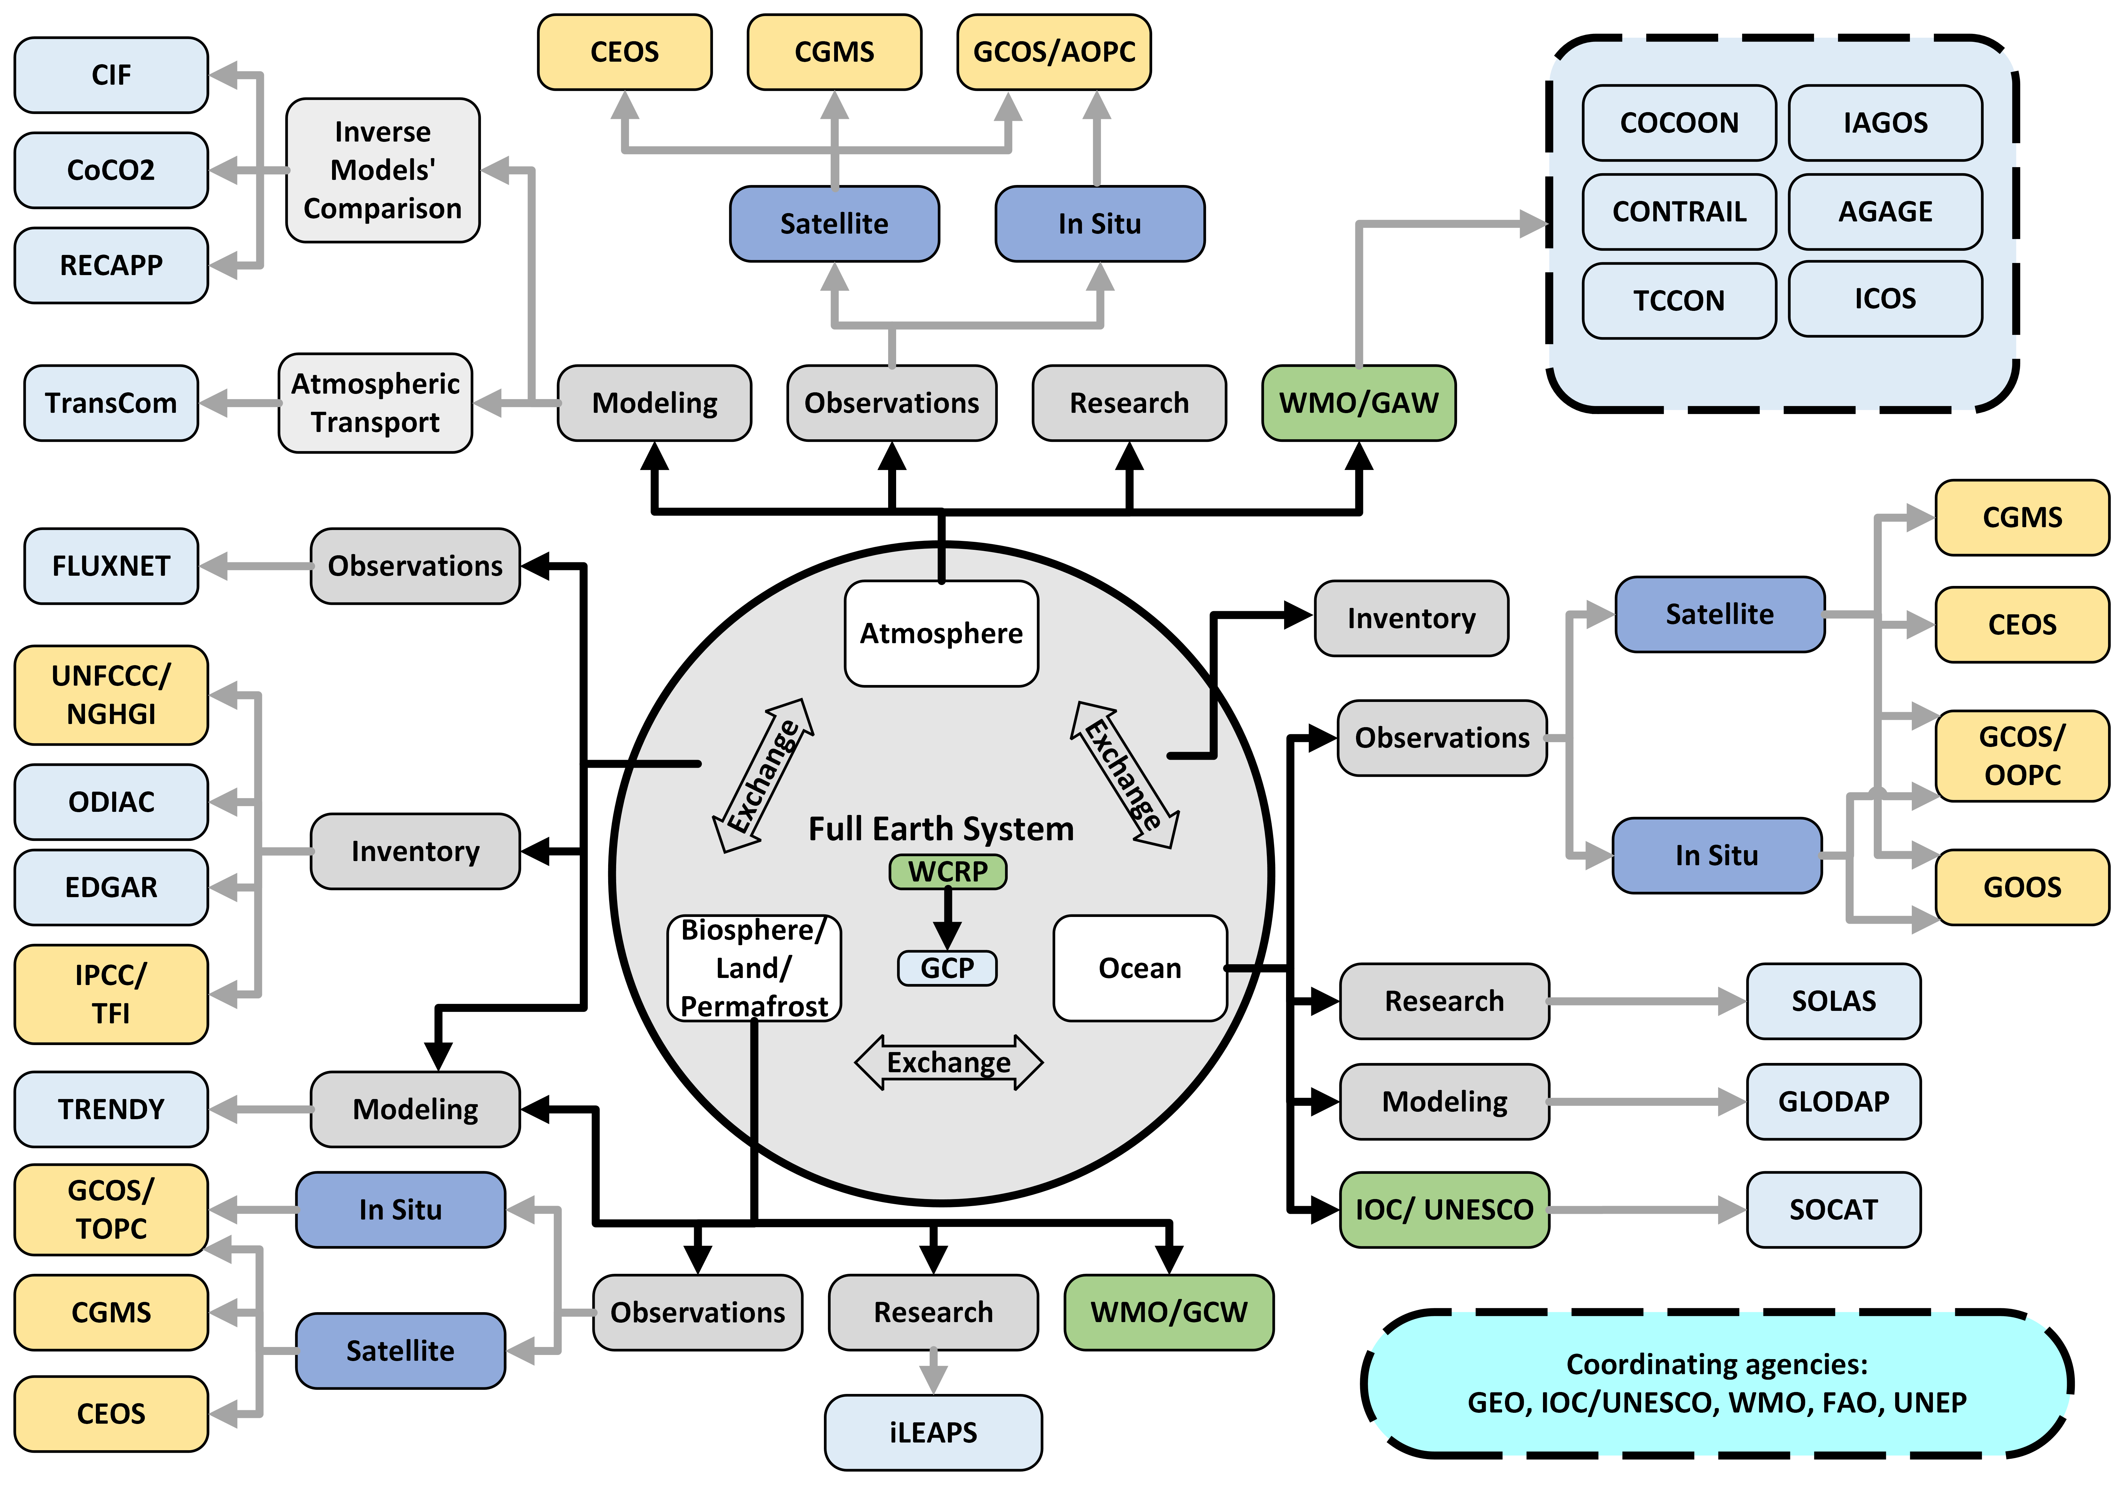
Figure 3. Stakeholder mapping
  - Role of WMO
There are two main reasons why WMO is well positioned to play a central role in coordinating a GGMI.
First, WMO has ongoing activities and experience in three of the four main areas listed in Section 3.1: Surface- and space-based observations of both basic weather variables and minor atmospheric constituents, international data exchange, relevant modelling and data assimilation efforts, and research via GAW and IG3IS. Via the Global Climate Observing System (GCOS) and its collaboration with UNEP, WMO has some activities in land-surface observations, and via GOOS and collaboration with the Intergovernmental Oceanographic Commission (IOC), significant activities in ocean observations and ocean modelling.
Second, as an intergovernmental organization, WMO has decades of experience in coordinating international efforts, establishing international systems, and setting standards and best practices in closely related areas such as weather and climate observations (WIGOS, GCOS, GOOS), numerical weather prediction (World Weather Research Programme (WWRP) and the Global Data-processing and Forecasting System (GDPFS)), climate and Earth System Modelling (World Climate Research Programme (WCRP)), and measuring and modelling concentrations of minor atmospheric constituents (GAW). In particular, these processes will be applied for the application and selection of the participating global centres under the guidance of the Infrastructure Commission.
In addition, the WWW is a useful paradigm for the infrastructure envisaged here, since it encompasses observations, data exchange, modelling and data assimilation and common verification methods. It is individual WMO Members that make observations, run models, and deliver data to users. The WWW establishes the collaborative framework for those countries (“infrastructure” in WMO terminology), within which its Members operate the various system components in a way that lets them complement and leverage each other for maximum impact. Under the auspices of the WMO Convention, the WMO Members (countries and territories) set requirements for the observing systems, the international exchange of data, the global modelling and assimilation efforts, and the dissemination and verification of the global model fields. The systems themselves are operated by the WMO Members, either individually or as groups of Members. This paradigm needs to be expanded to include many other institutions and parties within the Member countries and internationally to allow for the full implementation of the envisioned infrastructure.
Analogous to the role played by the WWW in the NWP and the GAW Programme, the role of GGMI would be to establish:
- Requirements for an integrated surface-, aircraft and satellite-based observing system
- A design of a comprehensive surface-based observing system and national observing requirements, along the lines of WMO’s Global Basic Observing Network (GBON), accompanied by a funding mechanism for implementation and operation in developing countries, along the lines of the Systematic Observations Financing Facility (SOFF)
- Improved and timely exchange of all satellite-, aircraft and surface-based GHG observations, including the coordinated planning for future satellite observing systems
- Collaboration on common methodologies and practices for GHG modelling and data assimilation
- Common file formats and practices for exchange of model fields
- Common verification and validation methods
- Common guidance on methods for post-processing and down-streaming applications
The WWW does not produce or disseminate weather forecasts, and similarly it would not be the role of GGMI to directly provide estimates or verification of anthropogenic emissions. This is the purview of individual Parties to the Paris Agreement, assisted where needed by targeted systems such as IG3IS or as developed under the Copernicus program.
5.3 WMO research in the context of GGMI
A strong research component is required to continuously support and improve the proposed operational infrastructure. The GGMI itself builds on mature research but several open scientific questions related to surface fluxes and transport remain. The investigations of some of these questions will benefit from the GGMI output, while others are expected to help further develop the system itself.
Given the need to significantly expand the observational infrastructure, research and development of improved and more cost-effective measurement techniques will be important. The research community will play an important role in developing and testing prior inventory products, process-based flux models and provide guidance on the techniques that can be used for the sources/sinks identification. Advanced data processing will also be an important research topic, including the application of machine learning techniques and AI. Research community will play an important role in analysis of the GGMI output and developing downscale applications as an important user community.
6. GGMI in the context of the WMO Strategic Plan
The GGMI represents the transition into operations of certain elements of a long-standing research activity to support service delivery leading to climate action. It thus exemplifies how activities undertaken as part of strategic objective 3 (SO3, Research) will lead to new operational infrastructure (SO2), which will ultimately support service delivery (SO1). Implementation of activities under each SO is included in the WMO Strategic Plan and will be reflected in the operational plan. Existing groups and activities will be leveraged to the extent possible.
See EC-76/INF. 4(3–1) for the full concept note.
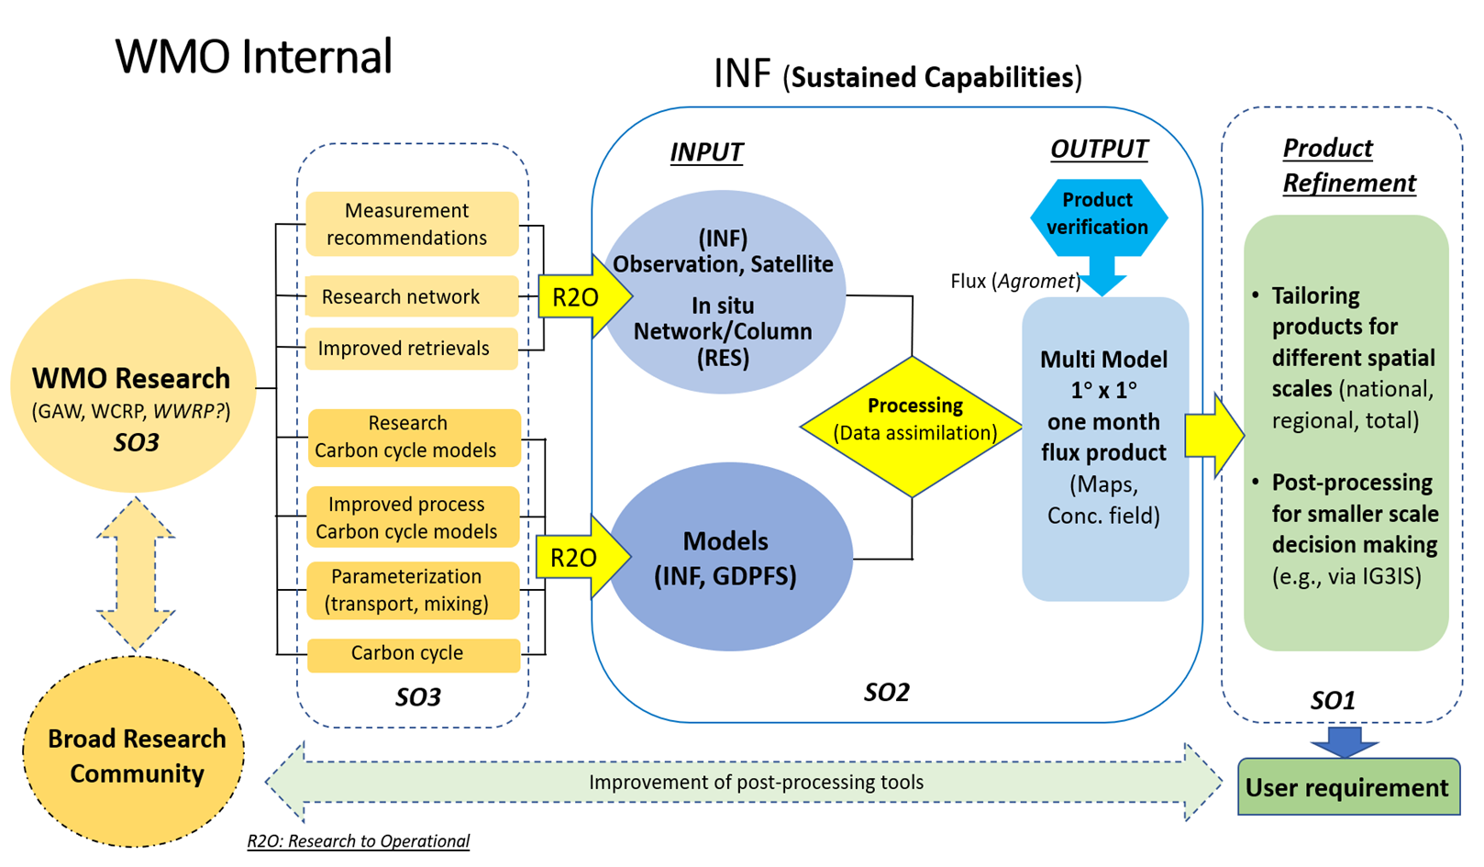
Figure 4. Alignment of the GGMI with the WMO Strategic Plan

_______________

Throughout this text, the term “greenhouse gas monitoring” refers to extraction of quantitative information about greenhouse gas abundances, fluxes and trends on a routine, sustained basis via the use of observations in conjunction with modelling and data assimilation. The physical and virtual facilities supporting this monitoring are referred to as “greenhouse gas monitoring infrastructure”.
In keeping with standard WMO terminology, the term “surface-based observing systems” (or networks) refers to any systems that are not deployed in space; the measurements may be in situ or remotely sensed, they may pertain to any part of the Earth System domain (atmosphere, ocean, land, cryosphere, etc) and to any vertical level within the respective domain.
The initial 1x1 degree resolution is based on the consensus expressed during the WMO GHG Monitoring Workshop in May 2022, and it reflect capabilities that are currently well within reach. The horizontal resolution is expected increase as both observing and modelling capabilities improve.
The Global Data-processing and Forecasting System (GDPFS) is in the process of evolving into the WMO Integrated Processing and Prediction System (WIPPS) which covers the whole Earth system.

